- CONTRACTOR’S SCOPE OF WORK/SERVICE

Solar Energy Corporation of India Limited (SECI) is having its Corporate cum Registered Office at 6th Floor, Plate-B, NBCC Office Block Tower-2, East Kidwai Nagar, New Delhi-110023. The Board Level Executives of SECI are sitting at 1st Floor, Plate-B, NBCC Office Block Tower-4, East Kidwai Nagar, New Delhi - 110023.
The various services required are as follows:
- General
- SECI Energy Corporation of India Limited (SECI) shall procure a “Software as a Service” and provide Manpower to carry out Power Trading Activities on behalf of SECI through Power Exchanges, DEEP Portal, and Bilateral Mode etc. on monthly Fixed Fee/Retainer Basis in line with the terms & conditions of this tender.
- The overall scope of work will include Design and Development of a customized Power Trading Software Solution in accordance to the needs to Power Trading business of SECI for seamless and smooth functioning and 3 years Operation & Maintenance support at SECI, New Delhi Office. The duration of contract shall be initially for a period of three years effective after end of trail period, which can be further extended based on the performance for maximum period upto 02 (Two) years at the same rate, terms & conditions.
- In order to do sale of power in market, be it merchant sale, real time trading or scheduling, a module needs to be developed with end to end integration which can cover entire short term power trading functions i.e. tender management, bidding, billing, reporting etc. The module also has to be flexible so that it can take care of dynamic regulatory changes and portfolio changes. The module should also be able to provide insights on power exchange & bilateral transactions so as to enable SECI to make an informed decision while also reducing manual efforts.
- The IT solution will be web based, and role-based access shall be given to relevant stakeholders of SECI for submission of data, bid submission, reporting, etc. The system will be sharing / exchanging data in real or near real time with centralized systems and internal systems for managing power trading functions and subsequently generation of energy statements, invoices, payment reconciliation, etc.
- Software/Portal should be responsive, i.e., to support a responsive page design compatible with multiple-size screens (Computer, Tablet, etc.). The layout and navigation panel position should be distinct and visible to the users.
- During the software development phase, the contractor shall designate a Project Coordinator/Project Manager who will serve as the single point of contact with SECI. The designated representative shall be responsible for coordinating with SECI, obtaining necessary inputs, incorporating the same into the software prior to the Go-Live stage, and visiting SECI’s office as and when required for discussions or reviews, preferably once in every fifteen days.

- The software shall be hosted on a secure Cloud platform (MeitY empanelled) and shall be managed by Bidder only for the entire period of the contract. The Contractor shall maintain availability of 99.5%.
- The tentative workflow of the module should be as follows:

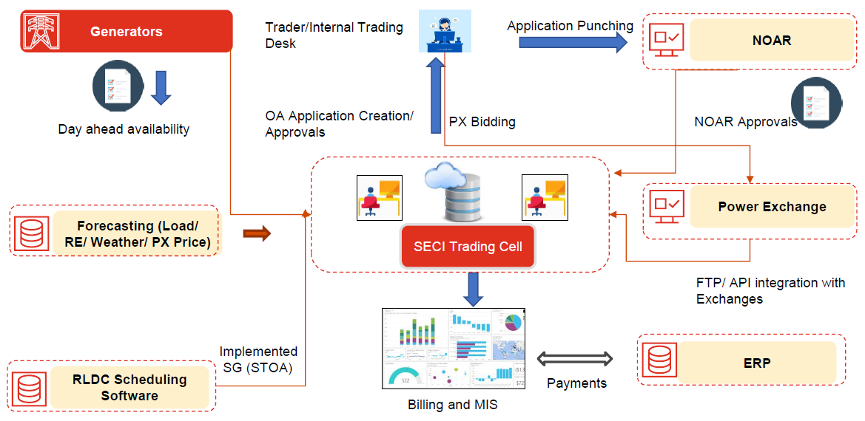

- Integrated Search Functionality: Provision of full-text search on the portal for all the content. When entering any keyword, the system must be able to search all links.
- Any planned downtime should be taken beyond the SECI working hours.

- The key deliverable sub-modules under the proposed software are:
- Client Registration Module:
- Client Portal for new client registration
- portal with an automated bidding system
- Power exchange and bilateral contact management and repository
- Power Bidding Module
- Power exchange bidding and Bilateral Trading
- NOC Management
- Bid Validation and approval
- Bid Upload functionality
- Automated bid preparation and formatted Open Access creation
- Open access and scheduling management
- API Integration with Power Exchanges, NOAR and GRID India
- Bid Replication Feature for DAM, RTM, TAM, GRTM etc. to streamline bidding
- Management and configuration of ISTS or other charges for billing
- Provision for direct client-side bid submission to the Exchange
- Billing and Energy Account Module:
- Power Exchange and Bilateral Billing
- Invoice generation: Energy, Open Access, Compensation, Refund etc.
- Payment accounting, TDS reconciliation
- Data sharing with ERP and integration of ERP with Power Exchange
- Dashboard and MIS Module:
- Dynamic dashboard for User and Client with all the required information (Market Analytics Real time).
- MIS report generation depending on the requirement
- Query based reporting
- Tender Management
- Market Monitoring Dashboard
- Optimization Dashboard for Battery Energy Storage Systems (BESS)
- LP Based Optimization & Arbitrage Module (BESS)
- Carbon Trading Module
- Integration with WBES for fetching and maintaining the registry of carbon credits
- Trading of carbon credits on exchange
- Repository maintenance and record keeping

- Power Trading Software Solution
Contractor shall develop a customized Power Trading Software Solution in accordance to the needs to Power Trading business of SECI for seamless and smooth functioning. Software Solution shall be capable to carry out functions including (but not limited to) the following
- To prepare software design document (blueprint) in consultation with SECI and to provide software provisions as per finalized design document. The solution shall be customized as per the requirement of SECI.
- Automatic generation of bids and automated process approvals for submission of bids by SECI and its clients for all Power Exchanges for all products including but not limited to the following
a. Day Ahead Market
b. Term Ahead Market
c. Green- Day Ahead Market
d. Real Time Market
e. Green Real Time Market
f. Green Term Ahead Market
g. Renewable Energy Certificate
h. Energy Saving Certificate
i. Renewable Purchase Obligations (RPO)
j. HP-DAM, Battery etc.
k. Carbon Trading & maintenance of registry
l. Ancillary services

- To create new clients for SECI, to perform user access and roles Management for external clients and SECI.
- To perform Bid validation including but not limited to pre-payment balance of client (total bid value + margin requirement).
- To perform bid edits/cancellations for users before the cut off time.
- To provide bid submission update, bid execution status update, bid Acceptance - Rejection, Daily obligation report, Settlement information etc. to clients via email/SMS.
- To provide Dashboard/Reporting feature to SECI & individual clients by collecting data from different sources available in public domain (CERC, CEA).
- To carry out Daily or Weekly billing/ Invoice from Exchanges and to reconcile bid data between Trading Portal & Exchange and also Energy Accounting.
- Updation/Up gradation of software from time to time in line with the statutory, regulatory and other requirements.
- Bilateral Transactions: Submission of Energy Schedules from clients to SECI, Updation of Schedule, Energy Accounting & Settlement, Billing/ Invoice etc. as required to carry out Bilateral Transactions.
- To advice SECI for forecasting of estimated price on Day-ahead & RTM basis regarding sale of power on Exchanges. API based integration with PX, RLDC, SLDC clients & any other stakeholders.
- To provide web-based software with a provision to provide role-based access to SECI employees including management officials, Sellers, Buyers, Traders registered on Power Trading Software/ Portal.
- To provide features for Battery Energy Storage System (BESS) Optimization - capable of capturing schedules of charging/discharging of the batteries. This will include assessing the prices in DAM/ RTM market and accordingly suggest charging/discharging timeslots considering surplus/ deficit scenarios. The software solution will provide features of forecasting demand, price and battery behavior, suggesting output for optimal dispatch, battery degradation related profile on Dashboard, etc. forecasting demand, price and battery behavior, suggesting output for optimal dispatch, battery degradation related profile on Dashboard, etc.
- Development of AI/ ML based data analysis.
- Manpower Deployment During O&M Period
- The Contractor shall deploy 01 (One) executive having minimum qualification of B.E./B.Tech /MBA (Finance/Power Management) and should have Minimum 02 years post qualification experience in the field of power market operations/ power trading/ energy scheduling.
- The deployed Executive shall work for 8 hours/day for 6 days per week and shall report to EIC at SECI’s Office in New Delhi or any other designated place during the contract period. The general shift timings shall be 9:30 AM to 6:30 PM (including 30 minutes lunch time break). However, the work timings and working days shall be as required to EIC as per work requirements. Further, the contractor must provide 24*7 remote support. The Contractor’s manpower shall fully associate with SECI manpower to enable SECI’s manpower to get fully conversant with power trading activities. Further, Contractor will provide additional manpower, in case required to SECI for managing the RTM / 24*7 requirements of clients on the same rates (provided in the BOQ item no 2 on pro rata basis) terms & conditions. In case the deployed executive is on leave, Contractor shall provide replacement of deployed manpower having similar experience, qualification & competency.
- Manpower shall be responsible to carry out the following functions:
  - Power trading activity on the software from end to end.
  - Exploration and analysis of various Opportunities available on Power Exchanges, DEEP Portal, Banking Option, Term Contracts, Bilateral Agreements, Round-the- Clock etc. as per Market Trends and arrangement of Clients/Customers and executing power trade transactions for SECI.
  - Coordination with potential clients through e-mail, physical meetings etc. to understand their power & portfolio optimization requirements and prepare proposals/solutions for the same.
  - Maintain database for potential buyers & sellers, competitor analysis, buying trends, key contacts, Policy and regulatory updates.
  - Provide advisory support for Selection of Target products (DAM, TAM, RTM, Bilateral Products, Banking etc.) so as to maximize trading margin of SECI.
  - OA Reservation and scheduling of power on NOAR/RLDC/SLDC Platform and all necessary formalities as per requirement.
  - Energy Accounting , Reconciliation and providing assistance to SECI in commercial issues, including energy traded and revenue realized after accounting the regulatory, statutory, open access charges and any other incidental charges etc. during the contract period so as to provide a clear assessment of the profit earned by SECI.
  - Assist SECI in maintaining periodical regulatory compliances towards CERC, SERCs, RLDCs, Exchanges, including preparation of formats, submissions (if any) etc.
  - To provide Contractual support to frame agreements to cover and safeguard risks associated with the transactions etc.

